**SQL PIZZA SALES PROJECT (SSMS)**

**Retrieve the total number of orders placed**

Select count(order_id) AS Total_Orders

from orders;

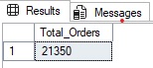

**Calculate the total revenue generated from pizza sales.**

Select

Round(Sum (order_details.quantity * pizzas.price),2) AS Total_Sales

from order_details join pizzas

on pizzas.pizza_id = order_details.pizza_id;

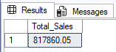

**Identify the highest-priced pizza.**

Select Top 1

pizza_types.name, pizzas.price

from pizza_types join pizzas

on pizza_types.pizza_type_id = pizzas.pizza_type_id

order by pizzas.price DESC;

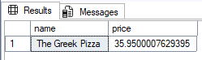

**Identify the most common pizza size ordered.**

select

pizzas.size, count(order_details.order_details_id) AS Order_count

from pizzas join order_details

on pizzas.pizza_id = order_details.pizza_id

group by pizzas.size

order by Order_count

desc;

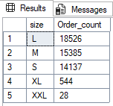

**List the top 5 most ordered pizza types along with their quantities.**

Select Top 5

pizza_types.name,

Sum(order_details.quantity) AS Quantity

From pizza_types join pizzas

on pizza_types.pizza_type_id = pizzas.pizza_type_id

join order_details

on order_details.pizza_id = pizzas.pizza_id

group by pizza_types.name

Order by Quantity

DESC;

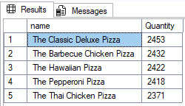

**Join the necessary tables to find the total quantity of each pizza category ordered.**

Select pizza_types.category,

Sum(order_details.quantity) AS Quantity

From pizza_types join pizzas

on pizza_types.pizza_type_id = pizzas.pizza_type_id

join order_details

on order_details.pizza_id = pizzas.pizza_id

group by pizza_types.category

Order by Quantity

DESC;

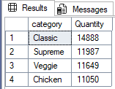

**Determine the distribution of orders by hour of the day.**

SELECT

DATEPART(HOUR, [time]) AS Hour,

COUNT(order_id) AS Order_count

FROM orders

GROUP BY DATEPART(HOUR, [time])

ORDER BY Hour;

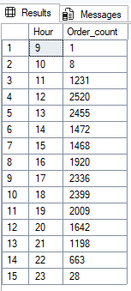

**Join relevant tables to find the category-wise distribution of pizzas.**

Select category, count(name) AS Distribution

from pizza_types

Group by category;



**Group the orders by date and calculate the average number of pizzas ordered per day.**

Select round(AVG(quantity),0) AS AVG_Order

from

(Select orders.date,

Sum(order_details.quantity) AS Quantity

from orders join order_details

on orders.order_id = order_details.order_id

Group by orders.date) AS Order_quantity;

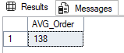

**Determine the top 3 most ordered pizza types based on revenue.**

Select Top 3

pizza_types.name,

Sum(order_details.quantity * pizzas.price) AS Revenue

From pizza_types join pizzas

on pizza_types.pizza_type_id = pizzas.pizza_type_id

join order_details

on pizzas.pizza_id = order_details.pizza_id

Group by pizza_types.name

order by Revenue DESC;

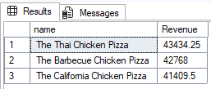

**Calculate the percentage contribution of each pizza type to total revenue.**

Select

pizza_types.category,

Round(Sum(order_details.quantity * pizzas.price)/

(Select Round(Sum(order_details.quantity * pizzas.price),2) AS Total_Sales

From order_details join pizzas

on pizzas.pizza_id = order_details.pizza_id) *100,2) AS Revenue

From pizza_types join pizzas

on pizza_types.pizza_type_id = pizzas.pizza_type_id

join order_details

on pizzas.pizza_id = order_details.pizza_id

Group by pizza_types.category

order by Revenue

DESC;

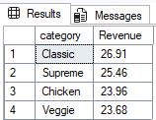

**Analyze the cumulative revenue generated over time.**

Select date,

Sum(Revenue) over(order by date)

from(

Select orders.date,

Sum(order_details.quantity * pizzas.price) AS Revenue

From order_details join pizzas

on order_details.pizza_id = pizzas.pizza_id

join orders

on orders.order_id = order_details.order_id

Group by orders.date) AS Sales;

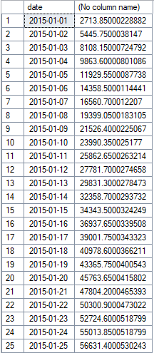

**Note: Only 25 rows are attached out of 358 rows.**

**Determine the top 3 most ordered pizza types based on revenue for each pizza category.**

Select category, name, Revenue

From(

Select category, name, Revenue,

rank() over(partition by category order by revenue desc) AS rn

From

(Select pizza_types.category, pizza_types.name,

Sum(order_details.quantity * pizzas.price) AS Revenue

from pizza_types join pizzas

on pizza_types.pizza_type_id =pizzas.pizza_type_id

join order_details

on order_details.pizza_id = pizzas.pizza_id

group by pizza_types.category, pizza_types.name) AS a) AS b

where rn <= 3;

